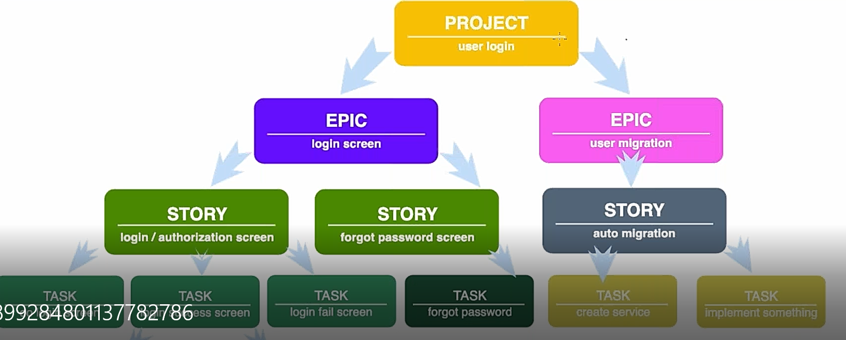

**WHAT IS SDLC**

**Software Development Life Cycle** (**SDLC**) is a **process** used by the software industry to design, develop and test high quality softwares. ... It is also called as **Software Development Process.**

**SDLC LIFE CYCLE**

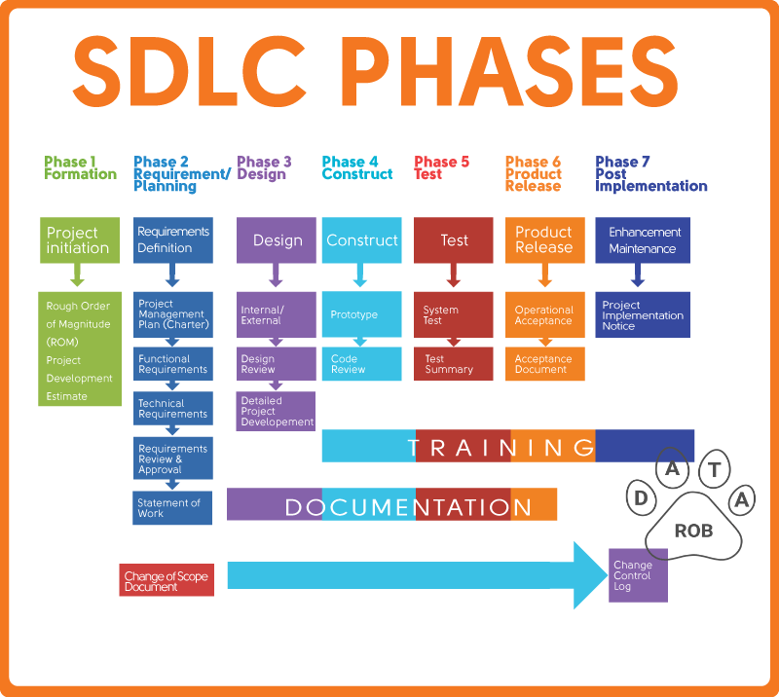

**SDLC MODELS**

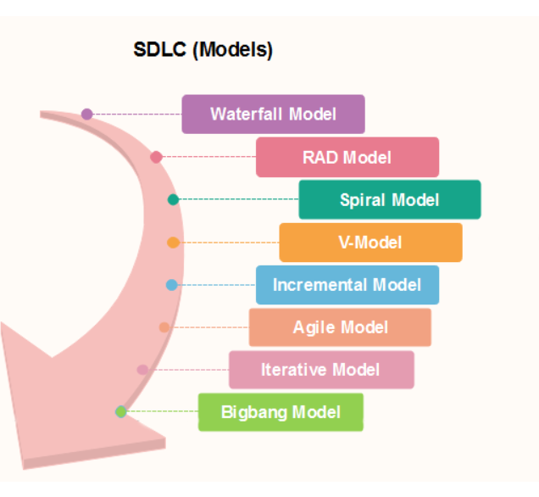

**EACH MODEL HAVING THE PHASES:**

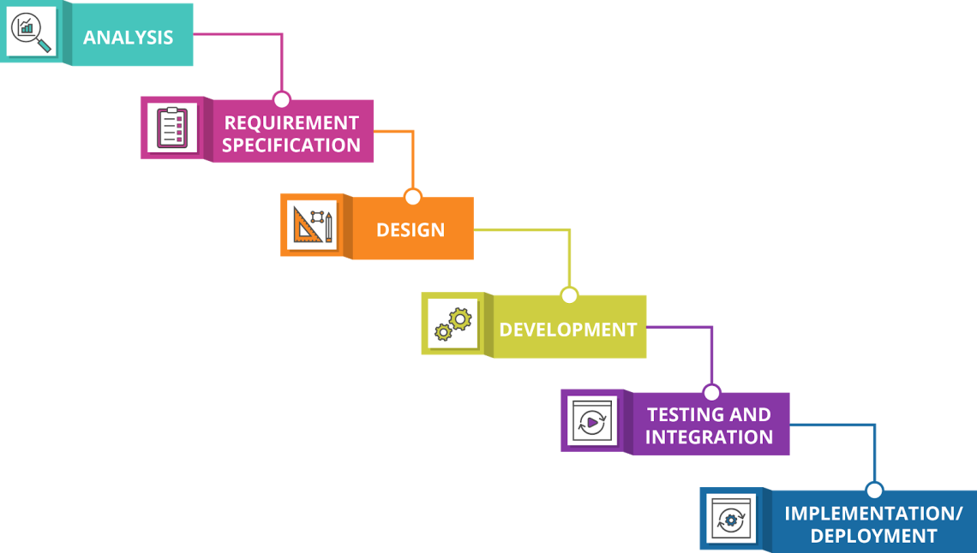

**Difference Between Agile and Scrum:**

The meaning of Agile is swift or versatile."**Agile process IS METHODOLOGY**" refers to a software development approach based on iterative development. Agile methods break tasks into smaller iterations, or parts do not directly involve long term planning. 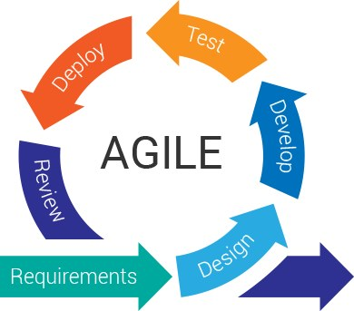

**Scrum:**

Scrum, on the other hand, is a subset of Agile. A Scrum is a simple and flexible Agile methodology for software development. The Scrum is not a technique or a process but a lightweight and simple framework to address complex problems of a project and deliver a high-value product creatively.

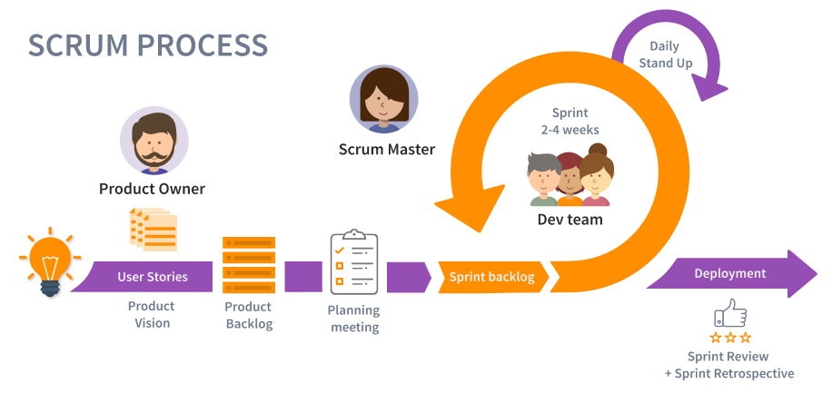

**What is azure devops**

**Azure DevOps** is a Software as a service (SaaS) platform from Microsoft that provides an end-to-end **DevOps** toolchain for developing and deploying software. It also integrates with most leading tools on the market and is a great option for orchestrating a **DevOps** toolchain.

Overview of the various offerings from Azure DevOps

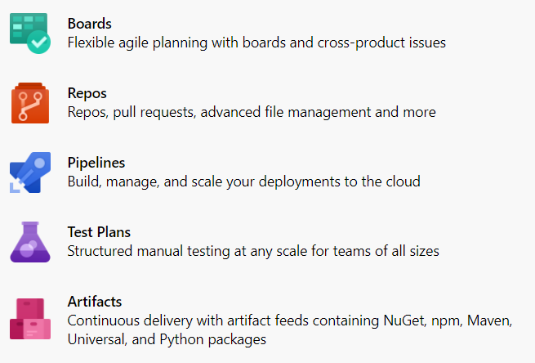

**Azure Boards**

Azure boards make the work of tracking tasks, bugs, and features a lot easier. In this, there are three types of work items: Epic work item which tracks features or any requirements, Issue work item which tracks bugs or any small changes and task work item which tracks works that are smaller than that of tracked by issue.

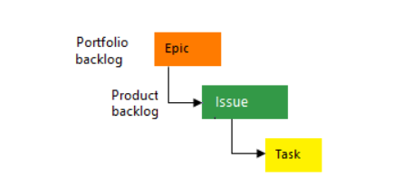

Also as the work gets completed the status gets updated stage by stage from:

* To Do
* Doing
* Done

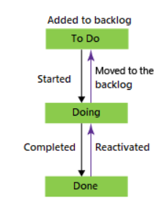

**Azure Repos**

Azure DevOps Repo or Repos is a collection of many version control tools that could be used to manage your code. It provides mainly two types of version control software: GIT repo and TFVC (Team foundation version control).

**Azure Pipelines**

The Azure DevOps pipeline can be used in creating and testing your code automatically and also in giving access to other users. As it is a combination of Continuous Integration and continuous delivery, it can produce consistent and good quality code with using both of them.

For public projects, Azure pipelines are completely free while for private projects, you can get 30 hours of it free for every month. You might be wondering what azure pipelines are, we saved it for a later discussion.

**Azure Test Plans**

By using Azure Test plans, you can test your application manually and also run exploratory tests. You can perform unit and function tests as well. You also have continuous testing enabled! Also with Azure test plans, you can request, provide, and track feedback.

**Azure Artifacts**

Azure artifacts are executable files and thus contain only machine instructions rather than human-readable higher-level code. A Feed is something like a container of packages that helps in consumption and publishing. Now coming to Azure artifacts, it is a store that contains all your artifacts which you have produced during development and deployment. They provide a fast and secure feed of binary packages that are also easy to use. You can also use multiple feeds for organization and control of access to your packages.

